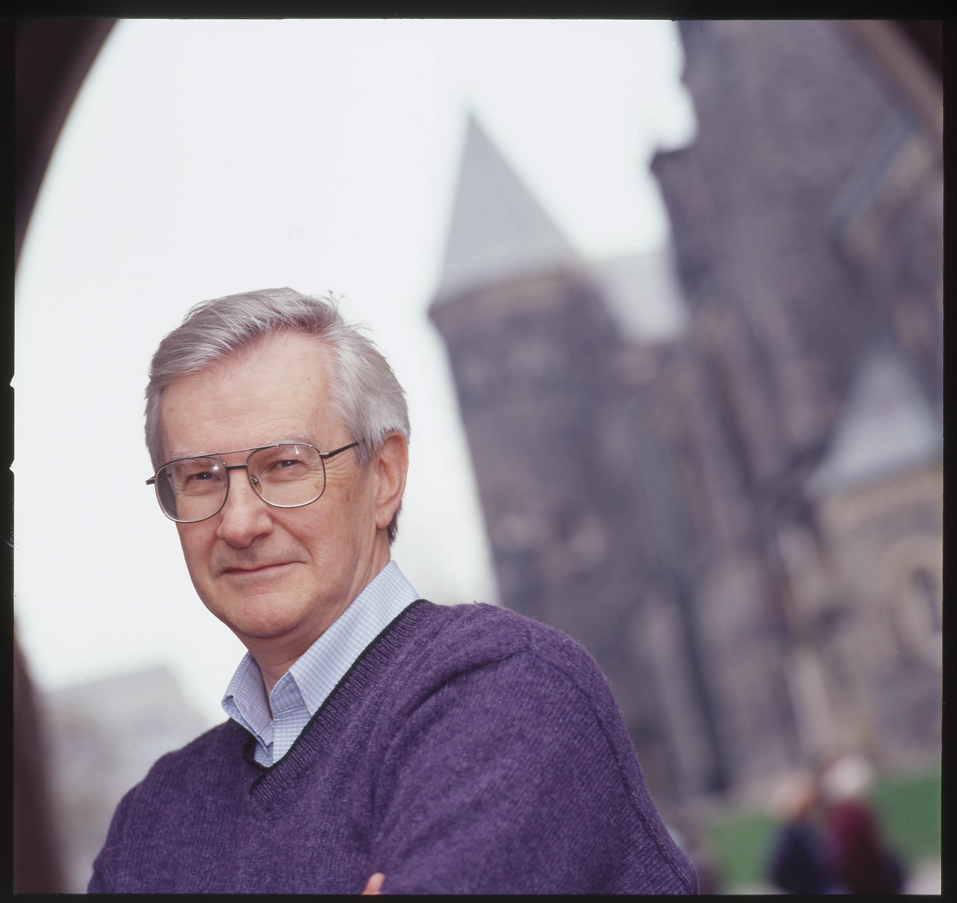

Bob Willard, Consultant and Author, Canada

Bob is the author of The Sustainability Advantage: Seven Business Case Benefits of a Triple Bottom Line (New Society Publishers, 2002). He is a leading expert on the business value of corporate sustainability strategies
and in the last three years has given over 130 keynote presentations to corporations, consultants, academics, and non-governmental organizations.

Bob applies business and leadership development experience from his 34-yearcareer at IBM Canada to engage the business community in proactively avoiding risks and capturing opportunities associated with sustainability
issues.

His latest book, The Next Sustainability Wave: Building Boardroom Buy-in (New Society Publishers, May 2005), was written in conjunction with his doctoral thesis at the University of Toronto. It examines why some
companies are committed to sustainability, why others are not, and how to overcome senior executive resistance to making that commitment.

More information about Bob and his work can be found at www.sustainabilityadvantage.com.

