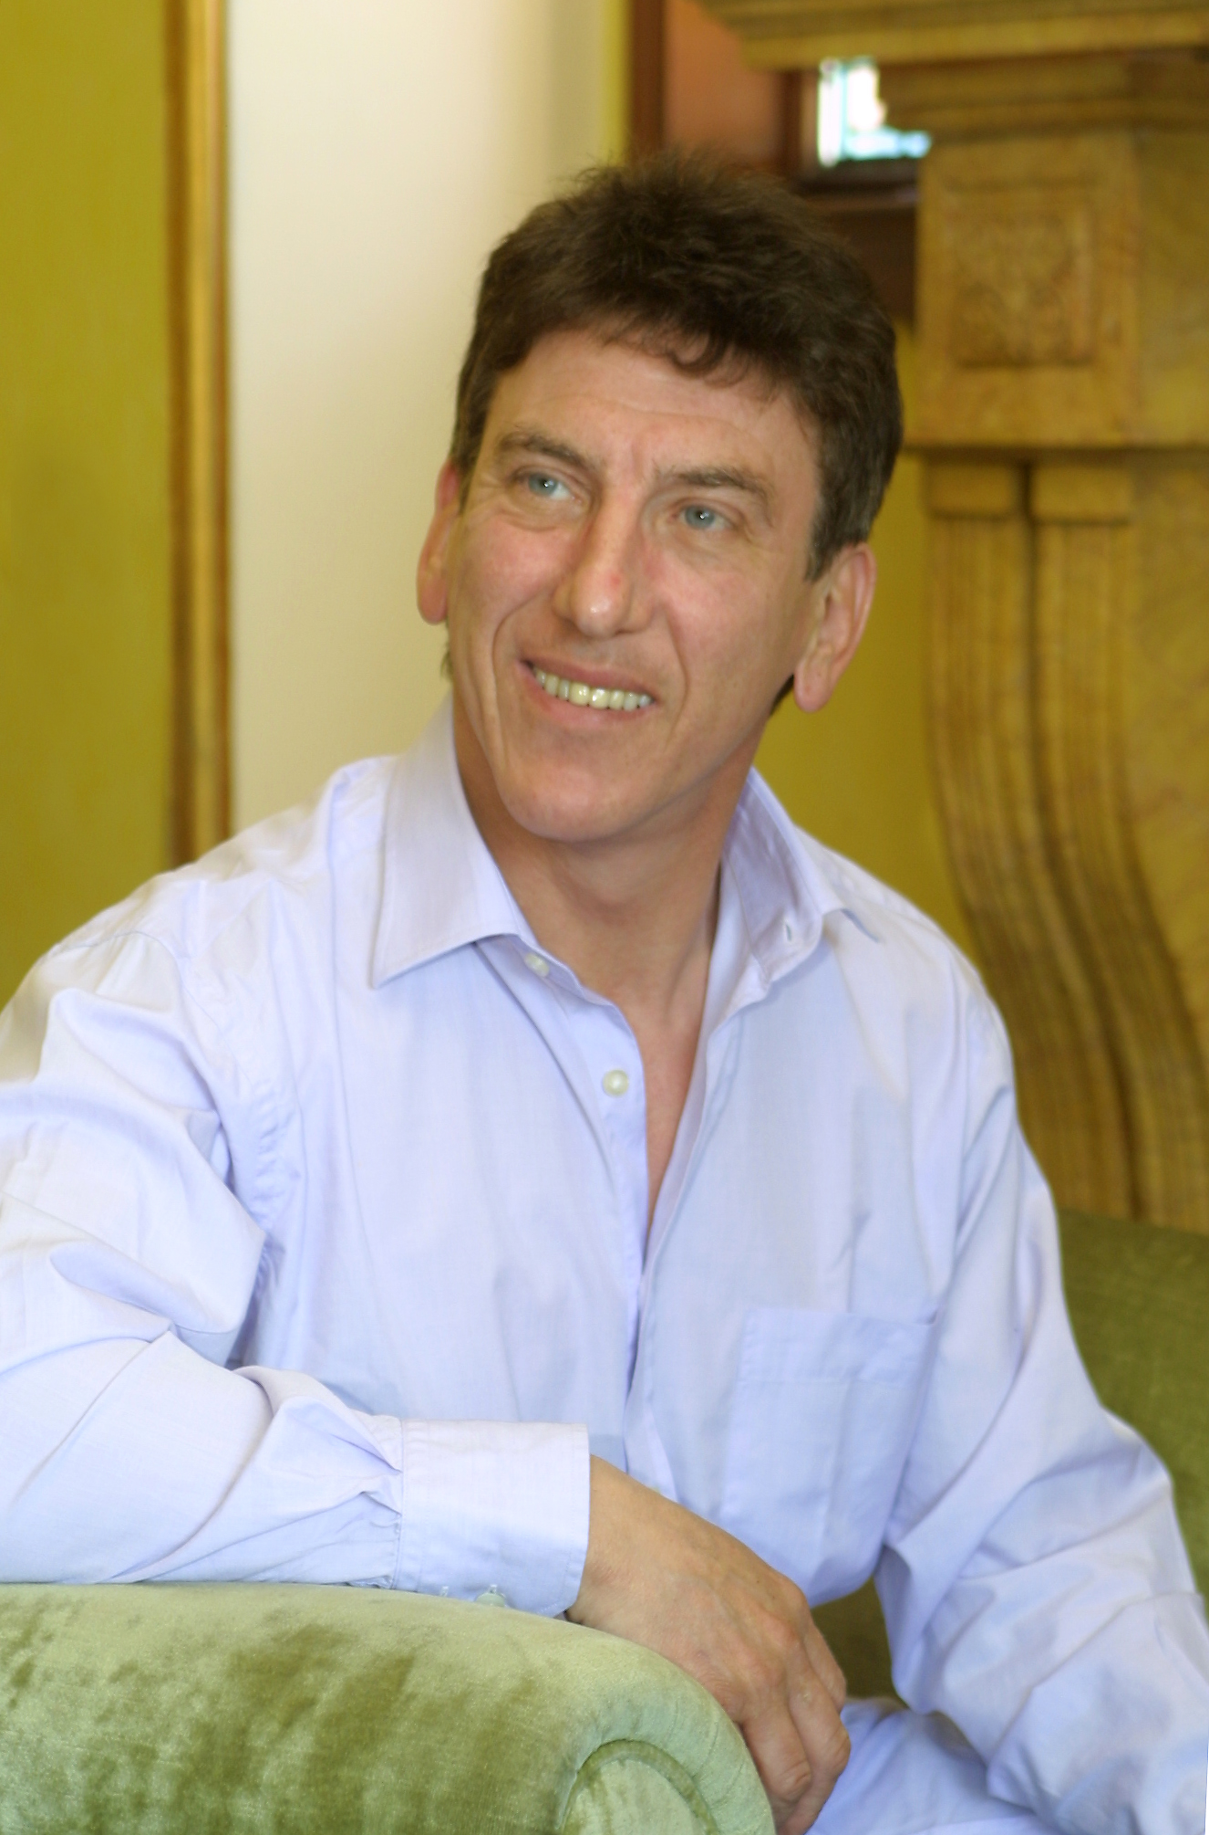

Dave Moorcroft, Consultant, Lloydmasters Consulting

Dave Moorcroft has a 1st class Honours degree in Applied Mathematics and Technology and a Masters Degree in Business Administration.

Dave has 30 years extensive experience across the BP Group in operational, commercial, organisational development and business development roles. At the BP Group centre he helped to develop a Group-wide risk assurance process, where his focus was on external issues of Corporate Responsibility and Business Ethics - culminating in the research and development of BP’s Global Policy on Business Ethics.

He was seconded to the World Business Council for Sustainable Development (WBCSD) in Geneva for 3-years as Director of Climate Change and Energy - to inform and influence the international public policy debate, at a critical juncture, on climate change, and to constructively engage some 100 leading multi-national companies in developing market based solutions.

On his return to BP, as Director of Sustainable Development, he worked on issues concerning BP’s social, environmental and economic impact. He led BP’s participation in the UN World Summit on Sustainable Development, the UN Global Compact and the World Bank’s 2-years Extractive Industries Review – a global public consultation concerning the impact of oil and gas projects on poverty alleviation and sustainable development.

Dave joined Lloydmasters Consulting at the beginning of 2004 in response to a growing, and apparently largely unmet, demand for expert and innovative consultancy on real world, pragmatic issues of sustainable development, corporate responsibility, corporate reputation and issue management.

