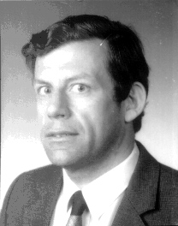

Prof. Dr. Ir. A.L.N. Stevels, Senior Eco-design Advisor, Phillips Consumer Electronics, The Netherlands

Albert Leendert Nicolaas Stevels was born in Eindhoven, the Netherlands, on August 31st 1944.

He studied Chemistry at the Eindhoven University of Technology and, after being employed by Philips Electronics Eindhoven in 1966, received a PhD in Physics and Chemistry at the Groningen University. In 1969 he joined the Philips Research Laboratories and worked on various subjects in solid state chemistry and materials science.

After moving to the Glass division in 1981, he worked in various capacities: glass technologist, laboratory manager, head of development and general manager of the Optics business. In 1989 he was transferred to the Consumer Electronics division (his assignments included: management of the Laser Optics business and projects in Asia).

From January 1st 1993 he has been senior advisor environmental engineering of Philips Consumer Electronics. From December 1st 1995 he was also appointed part-time professor in Environmental Design at the Faculty of Industrial Design Engineering of the Delft University of Technology.

