Sustainable Innovation with (Transnational) Technology Transfer

Ernst-Jan van Hattum, IRC Netherlands, former deputy manager & project advisor and o2 global network, chair, Engineer Industrial Design, Stallikerstr. 24, 8906 Bonstetten, Switzerland
Tel: +41 (0)43 466 00 85, email: ejvanhattum@bluewin.ch, http://irc.cordis.lu , www.o2.org,

Abstract
Why Sustainable Innovation with Transnational Technology Transfer (TTT)? In the conference text it is said:
- Scientists, businesses, trade unions and consumers must be mobilized in a strategy for a decisive change to use new technologies and learn new behavior
- To move towards more sustainable demand and supply-side patterns will require the creation, development, purchase and use of more sustainable products, services and product-service-systems (PSS)
- This will involve changes to buyer behavior at all levels (consumer, business and government)
- To achieve this will mean new thinking, (re)thinking and higher levels of creativity amongst all stakeholders

Technology Transfer means f.e. licensing technologies or know how for products, services or systems. The level of sustainability depends on the end solution or function that will be created. Transnational means between countries, but Technology Transfer could also be between regions or within a country.

Using Technology Transfer (TT) in the innovation process or at business level is like using building blocks of technology (like “Lego”), giving new ways for creativity and bringing creativity to a higher level. It helps to focus on functionality (technologies as building blocks to create a function) of the end-solution of the PSS (Product Service System) and to use new technologies for sustainable solutions. Further Transnational Technology transfer is a shift to service (enabling local companies to use the technology in local markets) versus exporting or importing products. It is a change in ‘buyer’ behavior at business, trade union and governmental level and a new way of thinking with a high potential for sustainable innovations.
International cooperation is an important aspect of cultural exchange between North-South, but in fact between every country and region. Cooperation means also a change in behavior, especially at R&D level (and certain at SME level). It means also local use of global technologies, what improves the fit of the sustainable innovation to the local market regarding consumption, resources and production processes: global thinking, local sustainable acting.

Further the exchange of know how from different technology areas (between Health and Transport f.e.) can improve the creativity getting to sustainable solutions. Transnational Technology transfer (or Know how transfer) basically will prohibit unnecessary transport of goods and can speed up the use of sustainable Product Service Systems, if used by those active with the most promising sustainable solutions.For governments is supporting TTT, like f.e. in the IRC Network, a new way to support organizations in both countries or regions, instead of giving subsidy to domestic organizations alone. This could be a more sustainable way of supporting organizations.

Speed and sustainable TTT
We are living in a world with an incrementing speed of new innovations that change our daily lives. It is therefore much harder to cope with new trends and technologies on sustainable innovations that matter for our business. We have seen trends too, that companies focused on core-business again; failing to choose the right trends; or getting too late “to-market”. Luckily times are changing, and cooperation of stakeholders, licensing or joint R&D on technology and sustainable innovations are increasing. The existence of the Innovation Relay Centre Network in Europe (see link list) shows this, besides other networks.
Why inventing when it already exists? Why not offering sustainable innovative technology that can be used in other geographical and technological markets as well? Why doing it alone when networks are there to help you? And sustainability is a framework demand of the European Commission. Of course the user himself defines the level of sustainability to be gained, but non sustainable technologies will not be promoted via the IRC Network. There are more than 1300 technology offers and – requests available.
And users can offer their sustainable solution to a plain technology request of someone else.
How it works (in general)
The question is if you are:
- an owner of an sustainable innovative technology and you want to market your innovation. The next step would be creating a technology offer, describing the technology and partner looked for.
- looking for new technologies to exploit or searching for an innovative solution to a sustainable technology need. The next step would be making a technology request.
After that, the offer or request would be send to the network, and people who see possibilities would react to you. Via the IRC network the offer or request could be anonymous (name, product market combination.
The same way of working could be applied within the informal worldwide o2 network on sustainable design, or other dedicated networks available worldwide (see link list)

Example “WinnerWay: Winning energy from infrastructure for heating and cooling”
A Dutch SME - called Winnerway.nl - has developed a concept for winning energy from the covering materials of streets, roads and buildings. The asphalt in the road surface is an excellent solar collector. Extraction of this energy prevents rutting of the roads and makes it possible to keep roads free of frost and snow on winter-days.
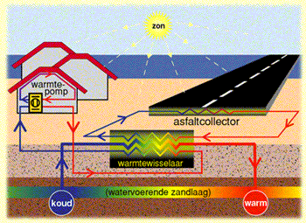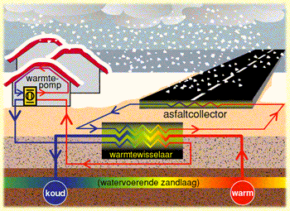
Fig. 1 – Summertime Fig. 2 - Wintertime

Examples of the concept can be found in The Netherlands and in Germany. The SME said it would be interested in meeting road constructors and building companies to realise the concept in their projects.
They put an technology offer into the IRC network, and the Province of Alessandria, Italy, reacted. They wanted to use it for their roads (Olympic Wintergames 2006 !) and local industries. The feasibility study showed good results and in April 2003 next steps has been taken for implementation.

Triggers for Sustainability in Technology Transfer
- Sustainable innovations or systems do not always exist of new technologies, but of a combination of good technologies
- A change from product to service, decreasing transnational transport and increasing local sustainable growth
- Sustainability in learning with other countries with their characteristics & attitudes and solutions.
- Sustainability in getting earlier to market with Sustainable Solutions vs non sustainable ones.
- Sustainability in re-using technologies & innovations, not wasting creativity and time.
- Sustainability in learning from other technology areas (technomimicry)
- Cooperation with other organizations helps you to get in time “to-market”
- Accelerating the use and application of Sustainable Innovations and – Technology via networks
- Licensing innovations that are not core business.

References

Jacobs, Dany and Waalkens, Jan, ‘Innovatie^2 – Vernieuwingen in de innovatiefunctie van ondernemingen’, Kluwer Deventer, 2001, pp.45-47

Man, Ard-Pieter de, Han van der Zee en Daisy Geurts, ‘Competing for Partners’, Prentice Hall, Amsterdam, 2000, pp. 148

