Success and Failure Factors of Product-Service Systems

Dr. Robert Wimmer, Head of Association, Centre for Appropriate Technology at Technical University Vienna, Wiedner Hauptstrasse 8-10, 1040 Wien, Austria. Tel: + 43 (0) 1 58808 49523, Fax: + 43 (0) 1 58808 49533 email: rw@grat.at, website: www.grat.at

Abstract
Product Service Systems (PSS) are a powerful concept within the marketplace and may, if carefully designed, contribute to sustainable growth. The underlying principle is that a company’s commercial 'value creation' goes beyond the production and distribution of material goods. PSSs are aimed at the satisfaction of clients and therefore carefully needs to address the real demands.
PSS and their role in the production and consumption process consist of three elements: technology (products), labour (use) and information (skills know-how). The importance of these three aspects may vary according to the specific case of a PSS, like the following figure shows.

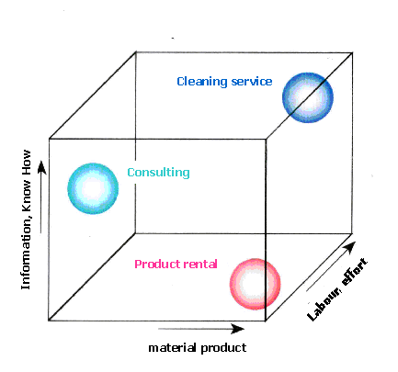

Fig1: Elements of a service system

The argument for PSS in the context of sustainable development aims at a cultural change from 'product oriented' to 'service oriented' consumer patterns. The planning and design of PSS facilitates the reorganisation of the “consumption–process” and provides potential opportunities for improved eco-efficiency.

On the other hand the increase of new Product-Service Systems is part of an economic trend creating a post-industrial society that is increasingly based upon information, reducing the importance of and dependence upon the primary and secondary economic sector.

This opens a new dimension of planning by offering less material-intensive Product-Service Systems that satisfy customer demands directly. The main challenge is steering this ongoing process into a sustainable direction.

Therefore a profound understanding of the system in question is an important requirement. Identification and selection of the relevant variables in the system, the stakeholders involved in the development and implementation process and the boundary conditions is essential for both, the economic success and acceptance of the PSS and the contribution to sustainable development.

Success strongly depends on the type of the PSS (business to business, business to consumer) the role and motivating factors for the involved actors in the value chain and competing solutions already on the market.

System analysis offers a tool to systematically explore the variety of development options and to identify key variables and indicators that are crucial for decision making in the process of PSS development. It can be applied to product-, labour-, or know-how intensive PSS.

The results of a system analysis for a European SME active in the production of surface treatment detergents based on renewable resources will serve as an example. The example will illustrate the new business perspectives that are linked with a shift from selling products to providing solutions for a given problem.

