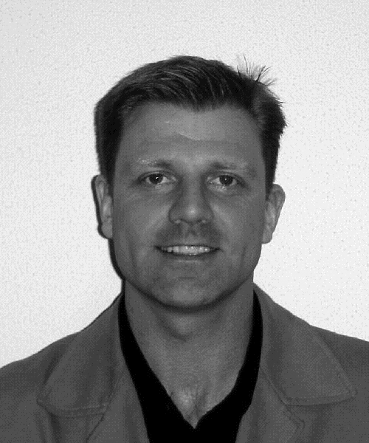

Dr. Chris Sherwin, Eco-design & Sustainability Consultant, Philips Environmental Services, The Netherlands

Chris Sherwin works as EcoDesign & Sustainability Consultant with Philips Environmental Services, CFT at Philips Electronics. In this role he offers support and consultancy in the 'greening and sustaining' of Philips products and processes and in moving the business towards the illusive goal of sustainability.

