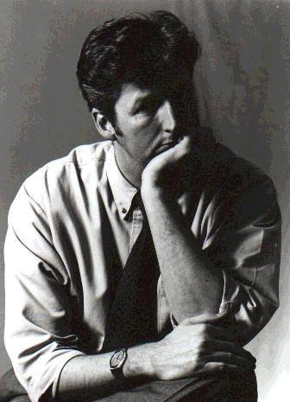

Darrell L Mann, Director, CREAX, UK

Darrell has spent most of his career to date, from the time he left school in 1980, until 1995, working for Rolls-Royce Aerospace. During his time at the company he worked in a variety of advanced engineering roles covering a range from computer programmer to propulsion systems engineer to aerodynamicist to strategy and programme manager in charge of the sustainability research underlying the company's shift from product-vendor to ‘power-by-the-hour’ service provider. He left the company in 1995 to undertake full-time research into systematic innovation and creativity methods at the University of Bath. Darrell first started using TRIZ in 1992, and has been teaching, developing products and solving technical and strategic business problems using TRIZ and related methods for a range of blue-chip companies since 1995. He is the author of over 100 patents, patent applications, and conference papers, and is a regular contributor to the on-line TRIZ Journal. With colleagues in Europe and the US he is pioneering the business concept innovation application of TRIZ and other methods. He is currently President of the European TRIZ Association.

