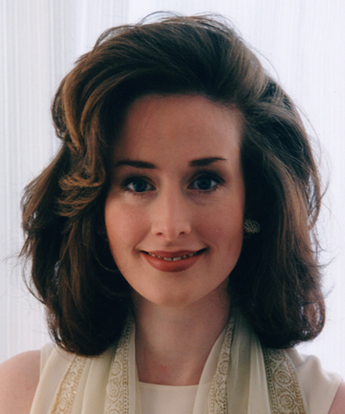

Dorothy Maxwell, Senior Environmental Specialist Environment Unit, Enterprise Ireland, Ireland and Environmental Policy and Management Group (EPMG)

Dorothy Maxwell has worked in the environmental arena for over twelve years in mainstream environmental consultancy to the public and private sectors. Her specialist areas of expertise include Clean Technology, Cleaner Production, Environmental Management Systems, Waste Minimisation and Sustainable Product Development. A native of New York City, she has worked as an environmental specialist in Europe, USA and Asia with international consultancies Andersen Consulting (now Accenture) and Willis Corroon Group. Currently based in the Environment Unit, Enterprise Ireland, she provides environmental expertise to business and industry and is managing the first Irish Sustainable Product Development initiative Environmentally Superior Products (ESP). She currently combines her professional work on ESP with a PhD research project on Sustainable Product and Service Development with the Environmental Policy & Management Group, Imperial College, University of London. She has produced a range of environmental publications for Business and Finance, the European Commission, Environmental Protection Agency and European Institute of Environmental Policy. She regularly lectures on environmental topics to industry and is a visiting lecturer on the Environmental Technology MSc at Imperial College, London. Dorothy holds a BSc (Hons) in Physics from University College Dublin and a MSc, DIC in Environmental Technology from Imperial College Centre for Environmental Technology, London.

