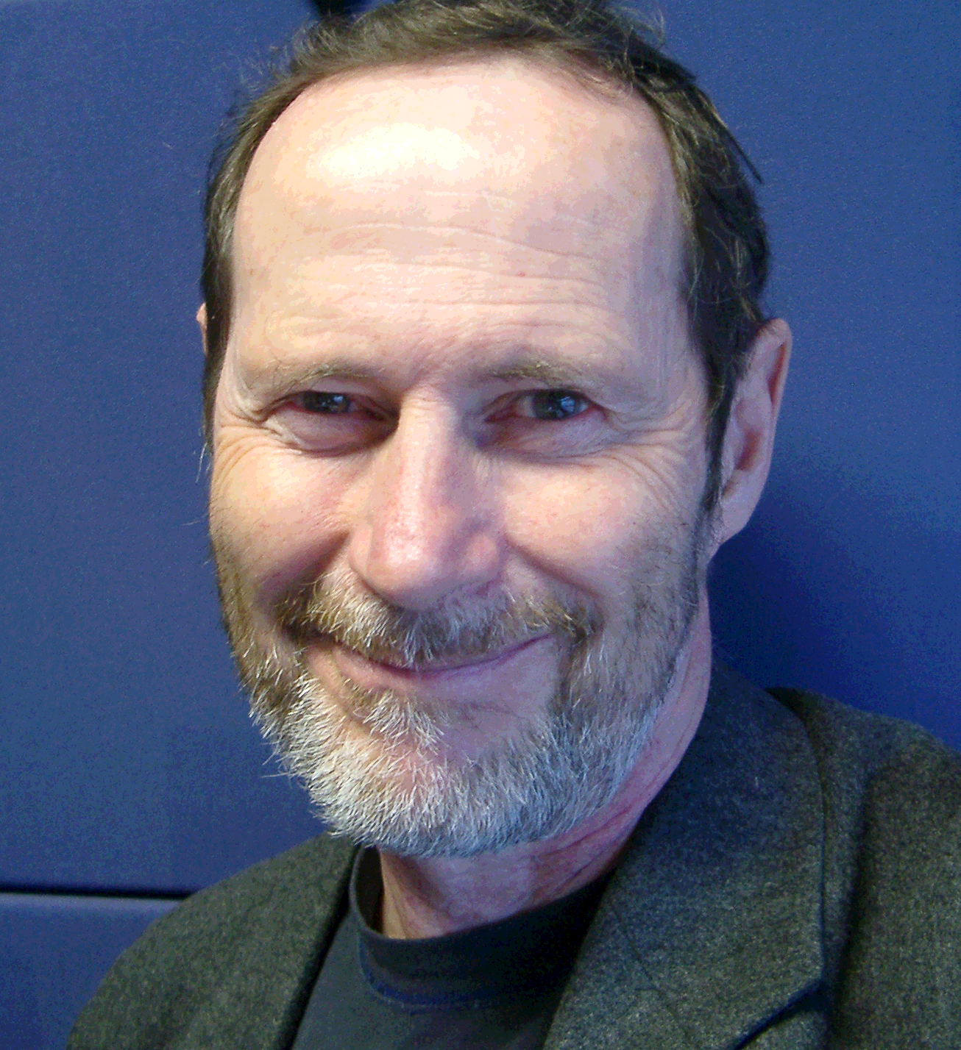

Douglas Tomkin, Faculty of Design Architecture and Building, University of Technology Sydney, Australia

Douglas teaches and conducts research projects in sustainable design. Prior to joining the University of Technology Sydney in 1998 as director of the Industrial Design program he was Chief Executive of the Hong Kong Design Innovation Company where he worked with Chinese, European and US marketing and manufacturing companies. Douglas is currently undertaking ecodesign projects in collaboration with the Shenzhen Productivity Centre and the Centre for Design at RMIT on issues related to the WEEE directive recently introduced in the EU.

