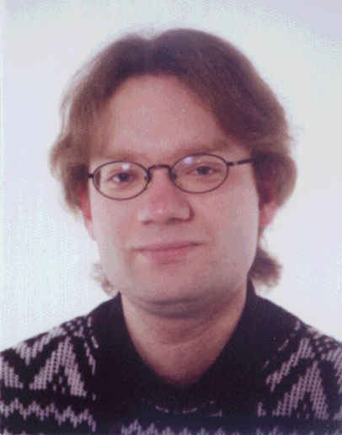

Jan Nill, Institute for Ecological Economy Research, Germany

Jan Nill, born 04/08/1971 at Ehingen/ Donau, economist. Studies at University of Trier, University Paul Valéry of Montpellier and Free University of Berlin. 1999 research fellow at the Berlin School of Economics; since 1998 journal editor (Ökologisches Wirtschaften) and since 1999 research fellow and project leader at the Institute for Ecological Economy Research (IÖW), main research areas: Innovation policy and ecological industrial transformation; European integration and EU enlargement

