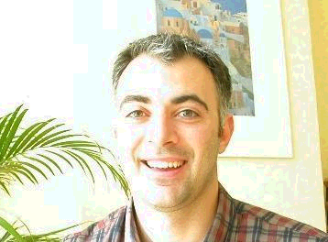

Luca Berchicci, Researcher, Design for Sustainability Program, Delft University of Technology, The Netherlands

Luca Berchicci is a Ph.D. researcher at Delft University of Technology in department of Design for Sustainability program (DfS). His research focuses on sustainable mobility, product innovation and network formation for product development. He graduated at Urbino University in Geology and after a period working in geophysical and geological matters he decided to go back to study joining the EAEME postgraduate course in Environmental Management at Polytechnic University of Athens and at Erasmus University of Rotterdam. On that occasion during the Ecodesign lectures he had the opportunity to meet Prof. Brezet and JC Diehl, then the step to be a research fellow in DfS department was very short.

