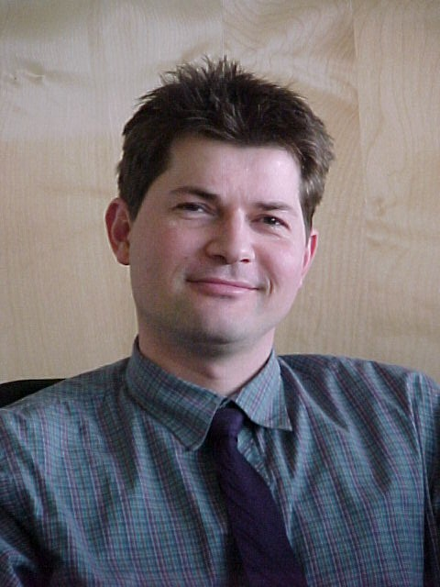

Marcel Collignon, Consultant, KPMG Sustainability, The Netherlands

Marcel advises multinational companies on integrating Sustainability issues in Business Processes. He focuses on Product Development (EcoDesign, Product Oriented Environmental Management Systems). From this experience, he advises national and local governments in developing incentives policy in this field. Before joining KPMG, he has worked as Consultant and Designer in the field of EcoDesign and Life Cycle Assessment, with TNO and PRé Consultants. He has studied Industrial Design Engineering at the University of Delft, The Netherlands

