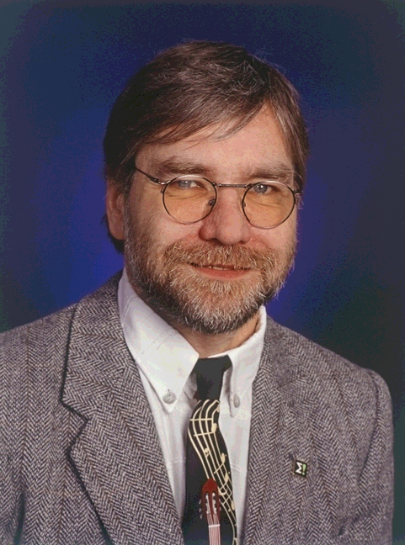
Mario Dompke, Deutsches Zentrum fur Luft und Raumfahrt, Germany

Mario Dompke, born in 1956, graduated as an engineer, gained 10 years experience in social impact of technological innovations in different fields within the governmental program “Humanisation of work life”. Before turning his attention to sustainability in the Project “Roadmap for ICT”, he coordinated several software development projects at the German Federal Ministry of Education and Research (BMBF).

