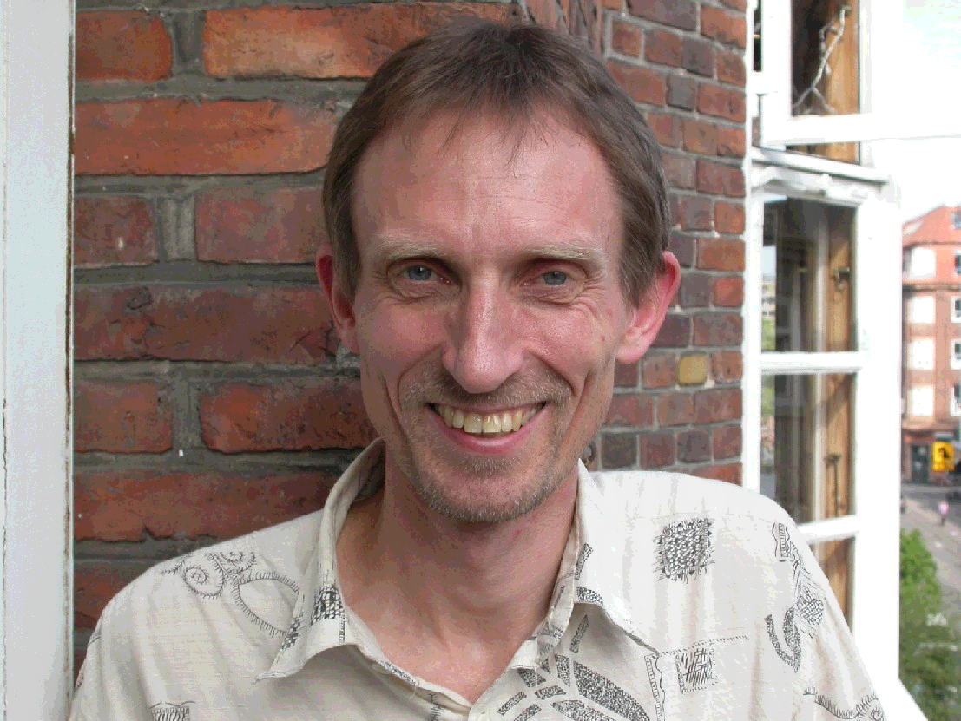
Michael Søgaard Jørgensen, Associate Professor, Department of Manufacturing Engineering and Management, Technical University of Denmark, Denmark

Michael Søgaard Jørgensen is an associate professor (since 1989) at the Section of Innovation and Sustainability at the Department of Manufacturing Engineering and Management at the Technical University of Denmark. Furthermore he is since 1985 the co-ordinator of the Science Shop, which is an open door to the university for citizens and NGO’s. He is a M.Sc. in Chemical Engineering from 1981 and has a PhD in Technology Assessment from 1988. His research is within environmental change processes in companies, product chains, branches and sectors. Part of the research is focusing on developing countries and the transfer of knowledge and technology between industrialised and developing countries. The research is based on a social construction approach and focuses on the competence development and on the environmental achievements obtained. The analyses of mechanisms involved in environmental change processes focuses on the interaction between the environmental initiatives and the technological and socio-economic mechanisms in the branch or sector in focus. Furthermore he does research on strategies for sustainable transition, including the use of methods like technology assessment, technology foresight and product chain analyses. His is teaching at graduate and post-graduate level in environmental strategies, product chain management and life cycle assessment.

