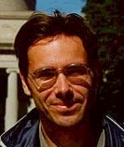

Robert van den Hoed, Delft University of Technology, Design for Sustainability, The Netherlands

Robert van den Hoed is finishing his PhD at the Delft University of Technology, Faculty of Industrial Design Engineering, section Design for Sustainability. His study focuses on the adoption of sustainable technologies, and uses the case of Fuel Cell Technology to examine factors which have made this take technology so popular for automotive firms to invest. Key questions include why this technology seems to be breaking through, why now (and not much earlier), if indeed we can expect breakthroughs in the coming years, and under what circumstances a breakthrough might be more likely to occur.

