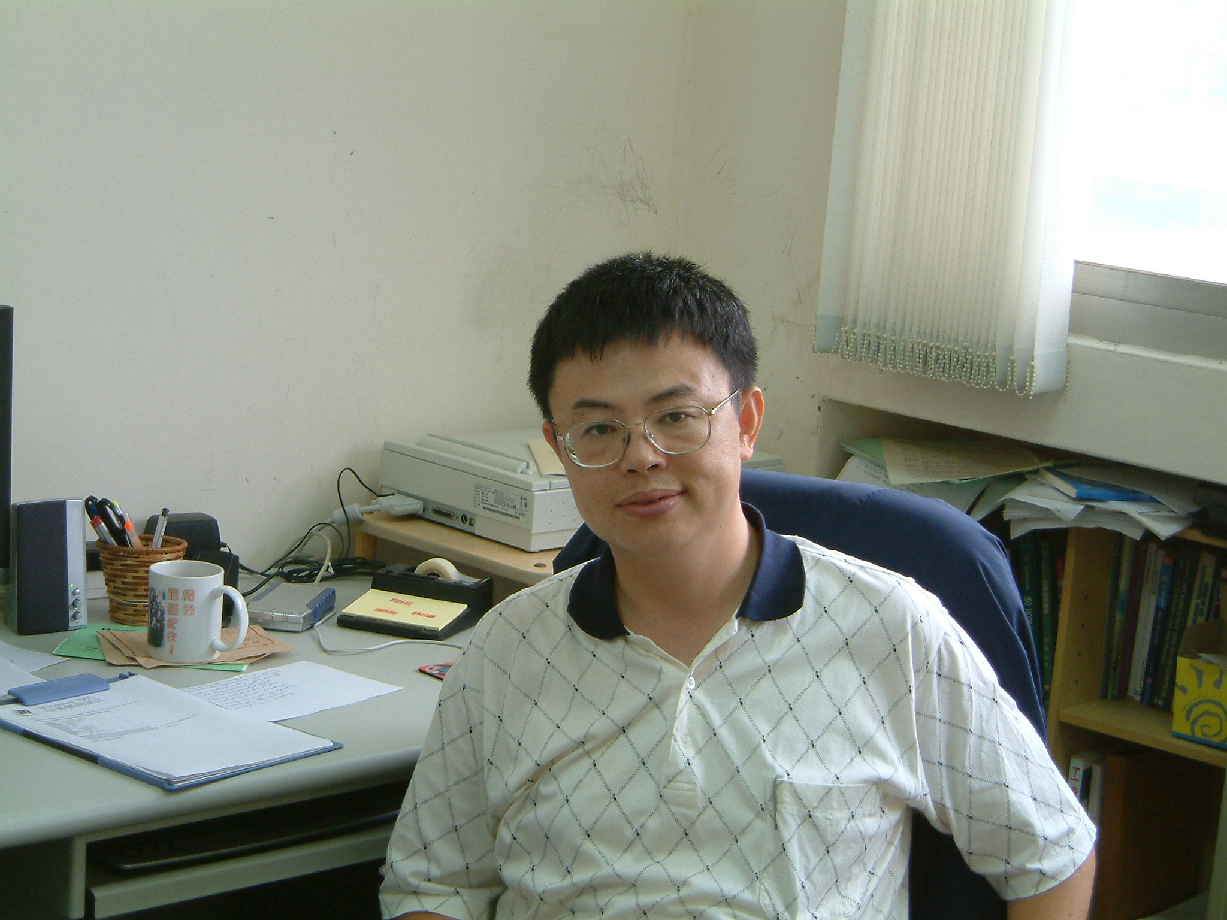

Sheng-Lung Lin, Assistant Professor, Chaoyang University of Technology, Department of Environmental Engineering and Management, Taiwan, ROC

Sheng-Lung Lin was born on 26 April, 1962 in Taiwan. He graduated in 1984 from National Cheng-Kung University, Tainan, Taiwan. He received his Master of Science Degree from National Taiwan University in 1986 in Environmental Engineering. He completed his military duty in the Army of the Republic of China. After that he joined CTCI consultant company, Taipei, Taiwan. He got his Ph.D. degree at Georgia Institute of Technology in Atlanta, US. Now, he is an assistant professor of the Department of Environmental Engineering and Management, Chaoyang University of Technology in Taiwan.

