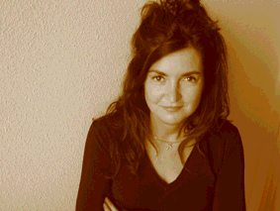

Simona Rocchi, Senior Design Consultant, Philips Design, The Netherlands

Simona Rocchi has an M.Sc. in ‘Architecture – specialisation in Industrial Design’ (Polytechnic University of Milan, Italy) and an M.Sc. in ‘Environmental Management and Policy’ (International Institute for Industrial Environmental Economics, Lund University, Sweden). She is currently a Ph.D. student in the international programme, ‘Cleaner Production, Cleaner Products, Industrial Ecology and Sustainability’ at the Erasmus Centre for Environmental Studies (Erasmus University, The Netherlands). She is regularly invited to give lectures at different European Universities and she is a visiting professor at the Faculty of Business Administration (Externado University, Colombia). She started her professional career at the Polytechnic University of Milan, working at the ‘Project-Product-Environment’ centre, dealing with environmental product policies and sustainable design strategies. She collaborated with international research centres such as the IIIEE at Lund University, Sweden and the IÖW Institute of Heidelberg, Germany. Since September 1998, she has been working for Philips Design, in Eindhoven, as a senior consultant within the Strategic Design department, dealing with sustainability-related corporate projects and design research activities. In relation to R&D activities, she patented a new method of investigation on users’ needs in contexts of use - as part of a new business model approach - in 2002. Within the Strategic Design group, she chairs the Sustainability Creative Solutions Platform and she is responsible for the internal sustainability programme. At Philips Corporate, she chairs the Task-force on New Business Models and New Markets. She is author of several publications on sustainability and brand/innovation design processes.

