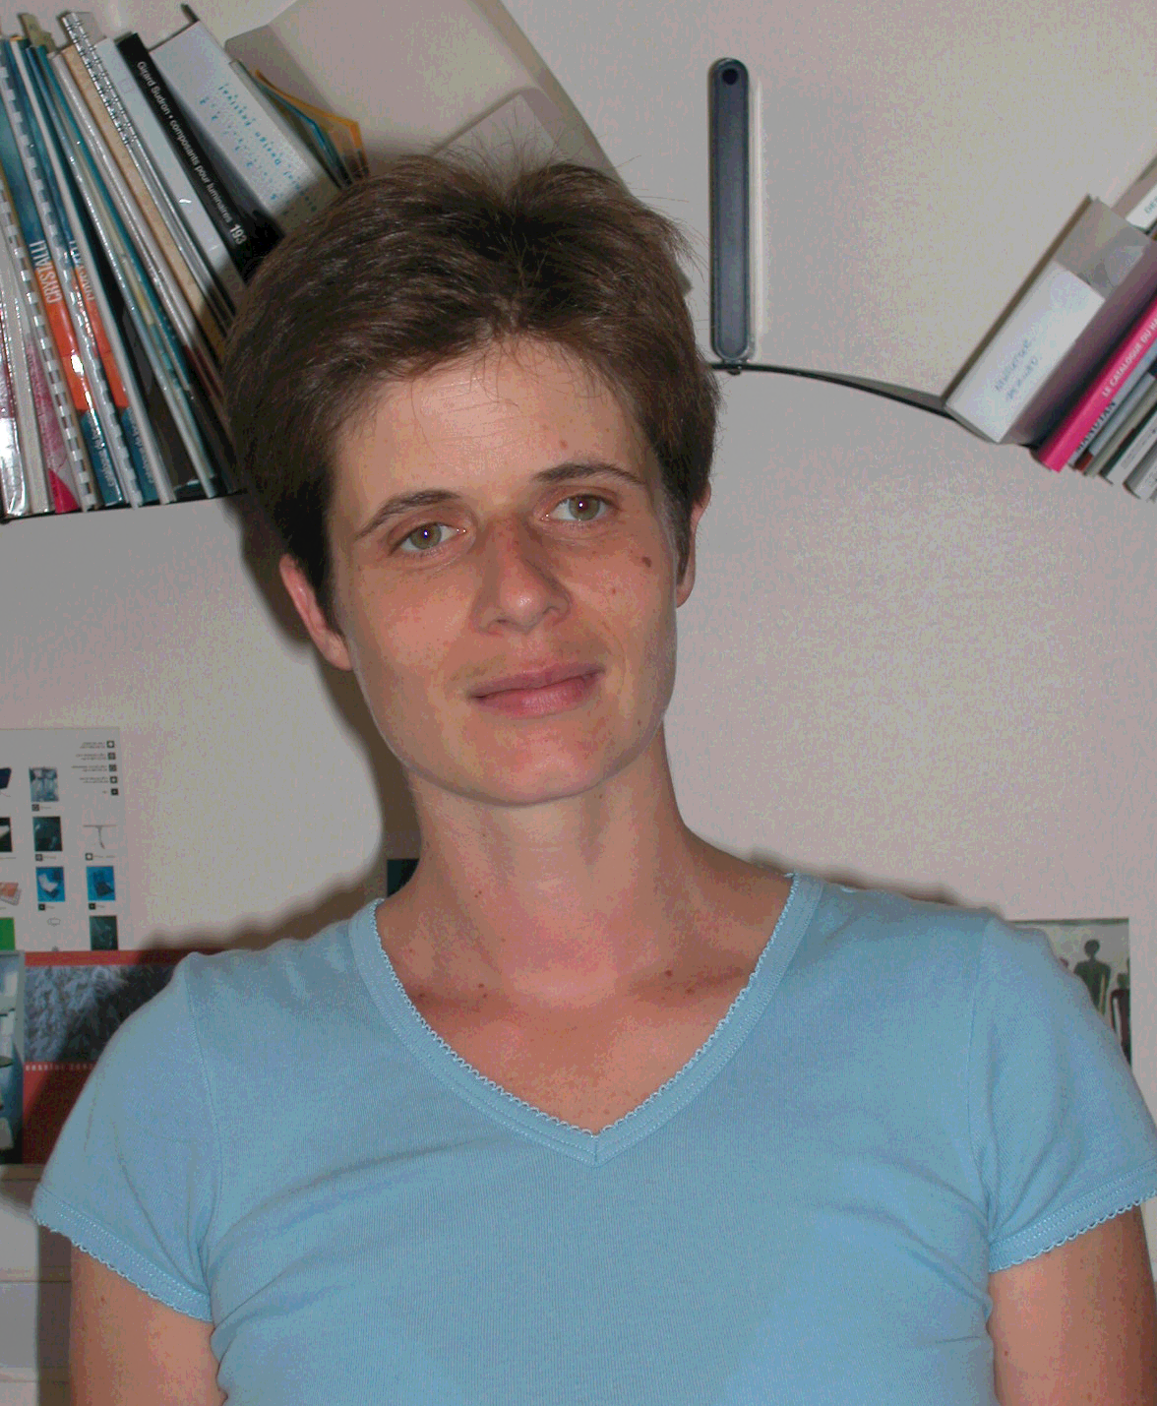

Sophie Labrousse, Centre Technique du Bois et de l'Ameublement (CTBA), Technical Center for Wood and Furniture, Furniture Department, France

Sophie Labrousse is an engineer in agronomic sciences. She has been working on environment projects for 10 years. She started as project manager for European projects in the Direction of Agriculture in ADEME. Since 1999, in CTBA, she has been in charge of developing environment projects for the furniture industry : environment management systems (14 001), eco design process, “NF Environnement” ecolabelling, …

