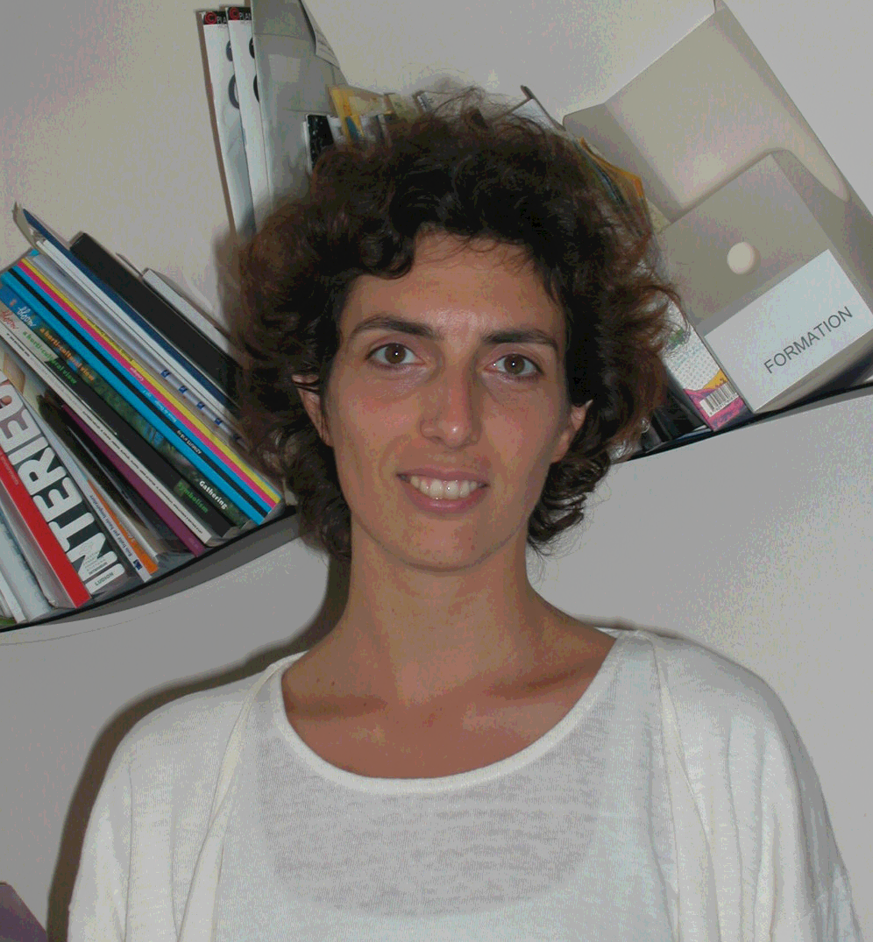
Susanna Campogrande, Centre Technique du Bois et de l'Ameublement (CTBA), Technical Center for Wood and Furniture, Furniture Department, France

Susanna Campogrande is an architect, graduated from Politecnico of Turin. Since 1999, she has been working as a designer and is in charge of developing the materials library in CTBA. She is research manager and responsible for consultation of Innovathèque.

