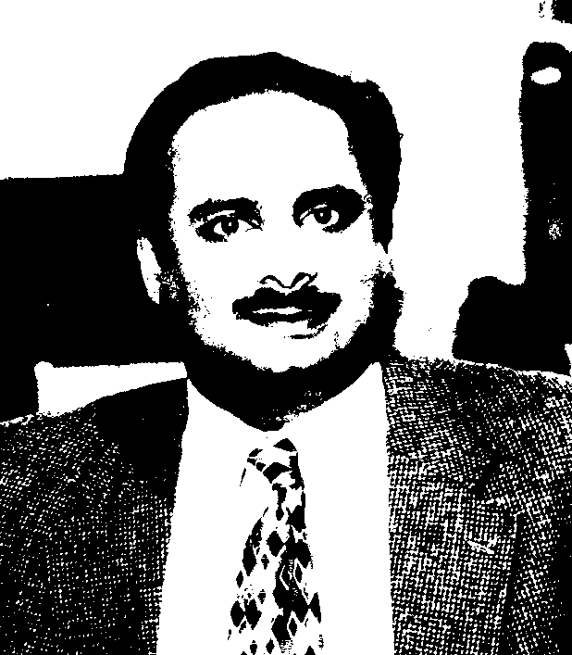

Venkat Allada, Associate Professor, Engineering Management Department, Director, Sustainable Design Lab, University of Missouri, US

Dr. Venkat Allada is an Associate Professor of Engineering Management and the Director of the Sustainable Design Laboratory at the University of Missouri Rolla. He has received two NSF grants relating to design for disassembly and sustainable product development. He is also a recipient of the 2001 and 2002 AT&T Industrial Ecology awards. In 1998, he received the Outstanding Young Manufacturing Engineer award from the Society of Manufacturing Engineers (SME) and the Outstanding New Faculty award from the American Society of Engineering Education (ASEE). His teaching and research is in the areas of sustainable product engineering, design for reuse, re-manufacturing, and reuse, and lean manufacturing.

