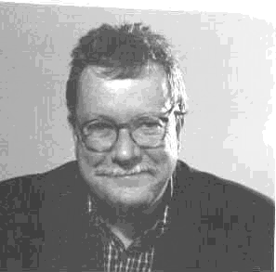

David Walker, Director, Giraffe Innovation, UK

David Walker is an architect, designer, and specialist in innovation and new product development After a first career in architecture (mainly in low cost housing) he moved to the Open University as a member of the Faculty of Technology. There he was course team chair of a pioneering course Design; Processes and Products and lead author on both Design and Innovation, and the Technology Foundation course. He transferred to the Open University Business School in 1987 to chair a course on Managing Design and be lead author of Creative Management.for the MBA. He is the author of around 50 OU units (50 page monographs). He has written and delivered around 30 analytical business case studies, mainly within the framework of MBA programmes Publications outside the OU include Managing Innovation Sage1991 (with Jane Henry) and Creativity for Engineers Woodhead 1991 (with Barry Dagger) He constructed and taught the MA in design management at the RCA in the period 1989 –1992. He has lived and worked for extended periods in Boston as Research fellow at the DMI, and also in Toulon, Hong Kong, Sydney and Auckland where he has constructed and variously contributed to post graduate programmes in design management and innovation. In 2000 with Robert Holdway he founded giraffe innovation consultants which specialises in new product development within ecological and ethical frameworks. Recent MBA case studies and business analysis for Cranfield University includes Liaoning Energy Management ( Bejing ) Domino Printing Science, Guardian Asset Management, Daler-Rowney, Brembo ( Milan) and DHL ( Brussels). Useful aphorism: ‘There is no such thing as a blank piece of paper.’

