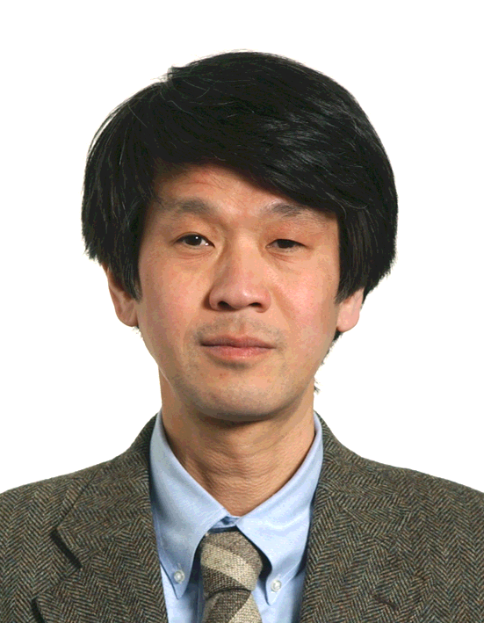
Dr. Katsuro Oda, Associate Professor, Institute of Industrial Science, University of Tokyo, Tokyo

Katsuro Oda received his doctorate in materials science from University of Tokyo. He holds appointment as an associate professor at the Institute of Industrial Science, University of Tokyo. His research interests focused on phase transition in materials, materials that display novel electromagnetic properties, and Eco-efficiency.

