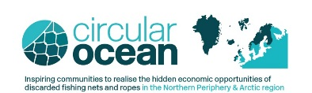

Circular Ocean Innovation Free Workshop 2017
Day 1 Day 2
17th July 2017 18th July 2017
Presentations and Serious Game #Net_Hack Challenge
Innovation Centre Iceland Reykjavik School of Visual Arts
Árlevnir 2-8 Hringbraut 121
112 101
Reykjavik Reykjavik
Iceland Iceland
The workshop is free but registration is required. Please tick which day(s) you will be attending and email the form to rcarruthers@ucreative.ac.uk
□ Day 1 □ Day 2 □ Both
Full Name ________ ____________________

Job Title _____________________________ _________ ____________

Organisation ____________________________

Address _____________________________________

Postcode __________________________________________Country ____________________

Telephone _______Mobile ____________________

Email _______Website ____________________________

Are you a SME (company with less than 250 employees) Yes [ ] No [ ]
If 'No' please advise what type of organisation are you _________________________________________
Ros Carruthers, The Centre for Sustainable Design®,
University for the Creative Arts at Farnham, Falkner Road, Farnham, Surrey, GU9 7DS, UK
Tel: +44 (0) 1252 892772 Fax: +44 (0) 1252 892747
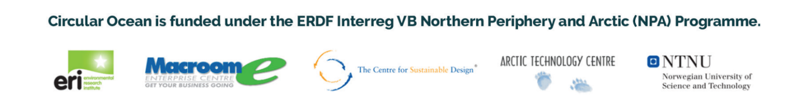
Email: rcarruthers@ucreative.ac.uk Website: www.cfsd.org.uk

